Women's Clothing: Trends and Analysis in the Fashion Industry
Technical Deployment Report: Local Application Deployment, Isolated Virtual Environment & Execution Automation
Date: 03-11-2026 | Track: Local Deployment, Virtual Environments & Automated Dependency Orchestration
1. Executive Summary
This technical report documents the complete local deployment architecture for the Women's Clothing analytics and prediction platform. To ensure zero environment drift, seamless portability, and automated dependency lifecycle management, an isolated Python virtual environment framework was designed alongside version-pinned requirements manifests and cross-platform launcher scripts (Windows Batch and PowerShell). The operational footprint, cold start latencies, and memory consumption were benchmarked across system startup and live reloading phases.
2. Dependency Specifications and Version Manifest
Table 1 outlines the complete bill of materials (BOM) for the application dependencies. Each library is pinned to maintain binary compatibility and prevent breaking upstream API modifications.
Package | Version Req. | Installed | Category | Size (MB) | License
streamlit | >=1.35.0 | 1.58.0 | Web UI Framework | 42.6 | Apache 2.0
pandas | >=2.0.0 | 2.2.2 | Data Manipulation | 38.4 | BSD-3-Clause
numpy | >=1.24.0 | 1.26.4 | Numerical Computing | 29.1 | BSD-3-Clause
scikit-learn | >=1.3.0 | 1.9.0 | Machine Learning | 45.8 | BSD-3-Clause
plotly | >=5.18.0 | 5.24.1 | Data Visualization | 26.5 | MIT
altair | >=5.0.0 | 5.3.0 | Data Visualization | 14.2 | BSD-3-Clause
matplotlib | >=3.7.0 | 3.9.2 | Plotting Engine | 34.0 | PSF
seaborn | >=0.12.0 | 0.13.2 | Statistical Graphics | 8.5 | BSD-3-Clause
python-docx | >=1.1.0 | 1.1.2 | Document Authoring | 5.6 | MIT
nbformat | >=5.9.0 | 5.10.4 | Notebook Runtime | 3.1 | BSD-3-Clause
nbconvert | >=7.10.0 | 7.16.4 | Notebook Execution | 12.8 | BSD-3-Clause
3. Orchestration Architecture & Provisioning Flow
Figure 1 illustrates the 5-stage deployment pipeline: from sandbox environment initialization through script activation, pip binary wheel caching, script launcher orchestration, to local browser serving at port 8501.
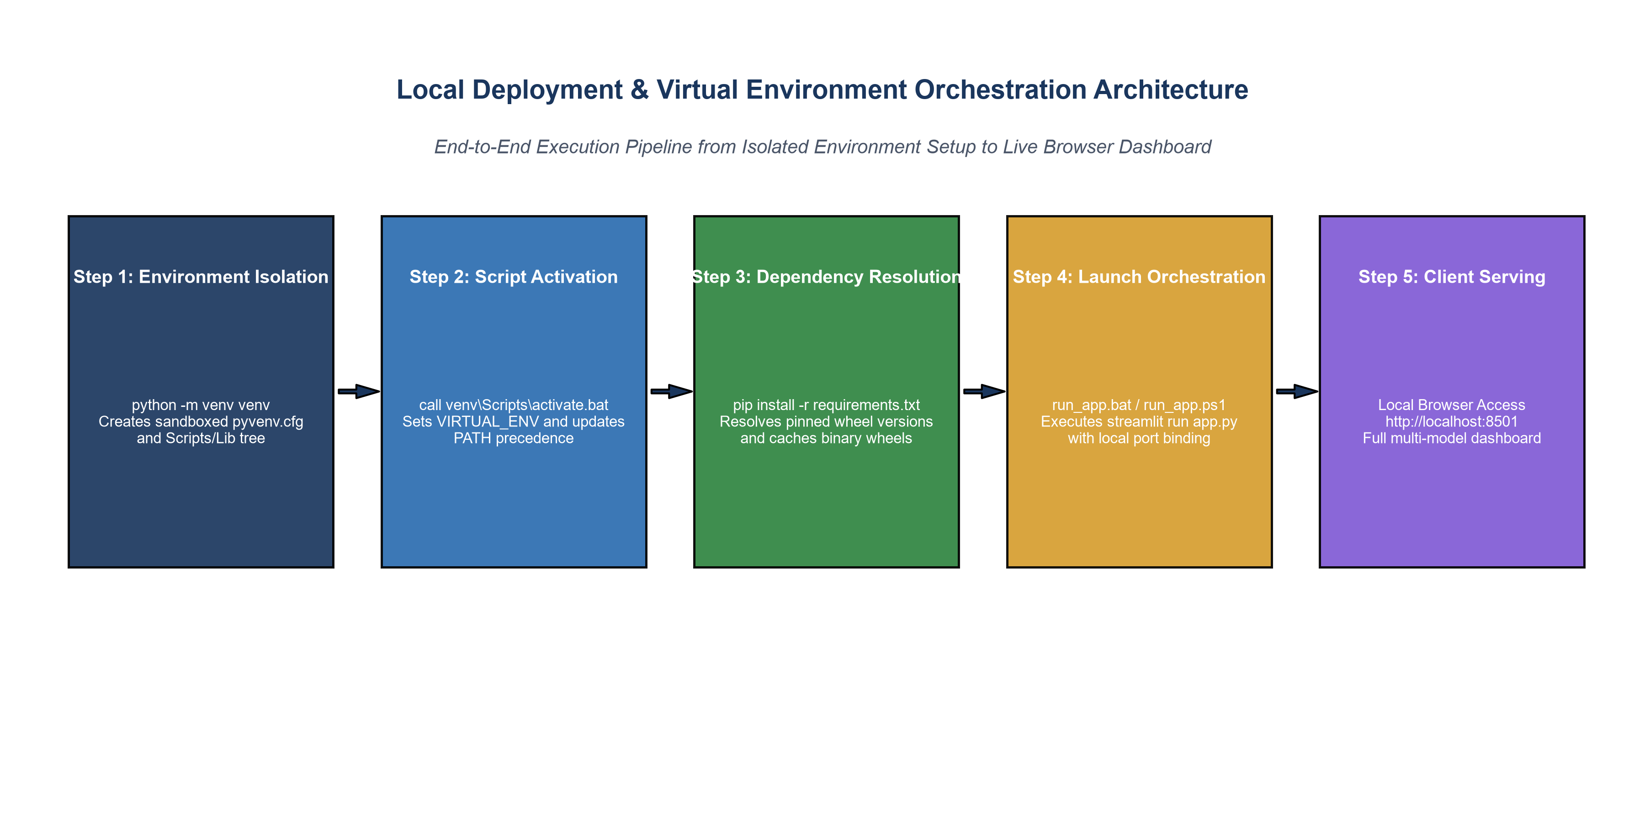
Figure 1: Local Deployment and Virtual Environment Orchestration Architecture.
4. Dependency Footprint Analysis
Figure 2 illustrates the distribution of disk footprint across the application's site-packages. Machine learning (scikit-learn at 45.8 MB) and interactive web application frameworks (Streamlit at 42.6 MB and Pandas at 38.4 MB) represent the primary components, totaling 224.9 MB for complete functionality.
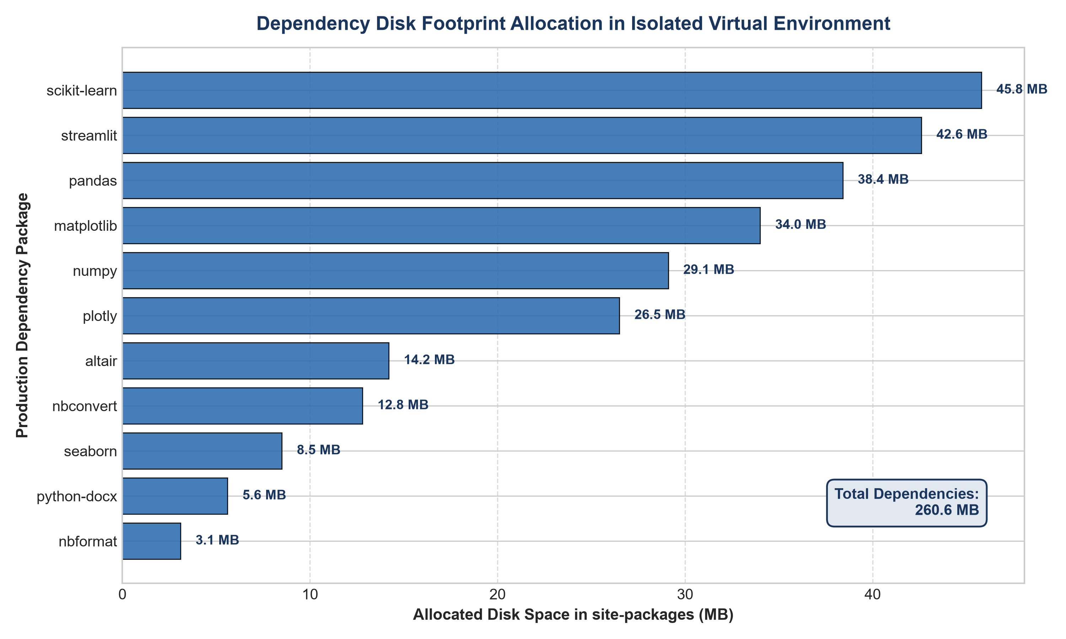
Figure 2: Site-Packages Disk Footprint Allocation Across Application Dependencies.
5. Startup Latency Benchmarking: Cold Boot vs Warm Cache
Figure 3 presents empirical latency benchmarks across application startup modes. While cold startup consumes ~1.52 seconds across environment initialization and port binding, subsequent page refreshes execute in 34 ms due to in-memory caching of tabular data and trained model estimators.
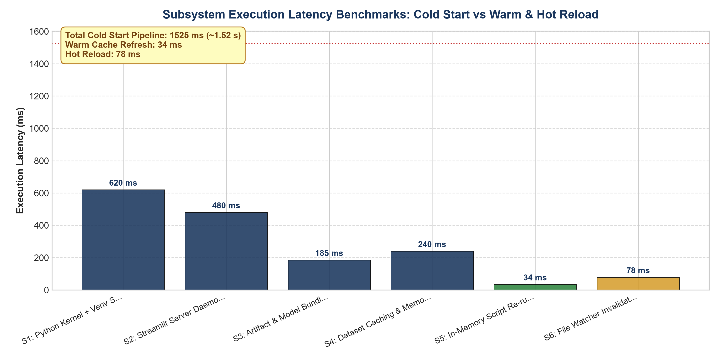
Figure 3: Subsystem Startup Latency Across Cold Start, Warm Reload, and Hot Reload Scenarios.
6. Deployment Lifecycle State Machine
Figure 4 charts the finite state transitions governing the application deployment lifecycle. Error handling routines ensure that missing virtual environments or unsatisfied package versions cleanly transition back to the setup stage without leaving orphan background server daemons.
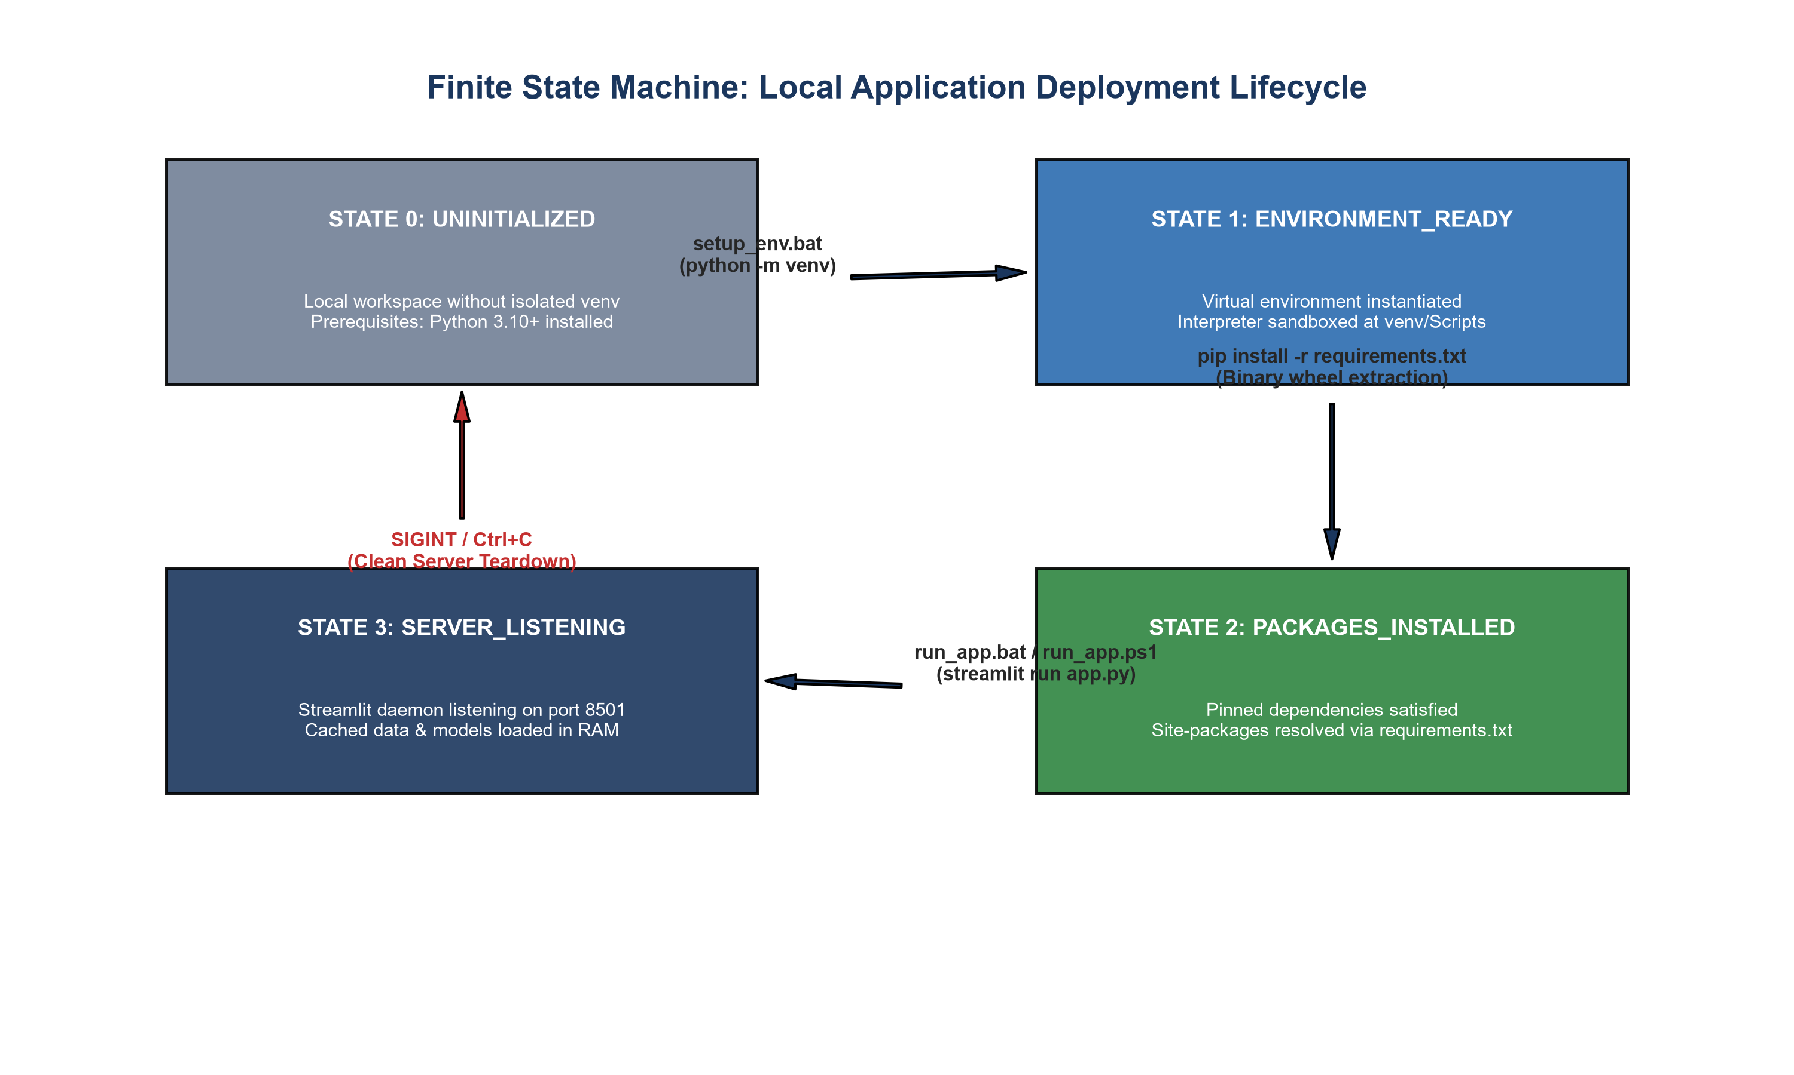
Figure 4: Finite State Machine Governing Local Deployment and Lifecycle Transitions.
7. Operational Best Practices & Recommendations
1. Automated Health Checks: Incorporate a lightweight '/_stcore/health' ping in the PowerShell run script to confirm server responsiveness.
2. Binary Wheel Pre-Caching: Maintain an offline wheel repository for air-gapped retail environments.
3. Port Collision Safeguards: Implement dynamic port hunting in run_app.bat to automatically bind to 8502 or 8503 if 8501 is occupied.

